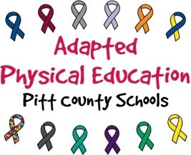
Paraeducator Responsibilities – Adapted PE
Pitt County Schools

As a paraeducator, you know the students you work with better than any physical educator or adapted physical educator in the county. Your assistance, guidance, and hands-on participation during PE are essential. Without your support, it is not possible for us to address the unique needs of each learner and provide our students a safe and successful environment during physical education class. The following is a list of responsibilities to be upheld during PE:

During PE/APE please assist with activities of the daily lesson by:
- listening to directions from the GPE (General Physical Education) or APE teacher;
- repeating directions/instructions to student(s) if/when necessary;
- implementing behavior management program consistent with the plan used in the classroom;
- helping students stay on task through motivation, prompting (physical and/or verbal), and positive reinforcement;
- monitoring, assisting, and supporting students throughout entire length of PE/APE class;
- using appropriate activity modifications of equipment, rules, etc;
- allowing student(s) to perform skills and activities as independently as possible;
- facilitating positive social interaction between students with and without special needs;
- encouraging GPE teacher to interact with student with special needs;
- assisting ECU volunteers when working with students with special needs (when applicable).
If you are injured or physically unable to participate and assist during class, you must:
- notify the GPE/APE teacher;
- provide a doctor’s note (if out for more than 3 classes);
- fulfill other GPE/APE duties that require little physical exertion, such as but not limited to;
  - keeping score
  - completing assessments
  - operating radio/music
  - operating stopwatch
  - giving directions/instructions
  - taking data
  - redirecting behavior
  - encouraging students.

**Please note that PE/APE is not a time for socializing with co-workers, talking on your phone, or taking a break. We need your help. Your students need your help. Please keep side conversations to a minimum, especially during stretching and whole class instruction.**

